MACHINE LEARNING
Short Answer Test — Set 2 (Applied Case Studies)
Probabilistic Diagnosis • Spam Detection • Segmentation • Concept Learning • Bayesian Finance

Assessment Type | Short Answer Test — Set 2
Number of Questions | 5
Marks per Question | 10
Total Marks | 50
Graded Against | 5-Criteria Calculation Rubric

How to read this document: Each answer is a complete Level-4 (Exemplary) response for its case study — it states the concepts and assumptions, designs the system, shows the calculation/reasoning, addresses every part of the question, and presents results with colour tables and diagrams.

Grading Rubric (per answer, 100% scale)
Criterion | Weight | Level-4 Exemplary descriptor
Conceptual Understanding | 30 | Clear & complete understanding of the concept
Accuracy of Answer | 20 | Completely correct answer with no errors
Application of Knowledge | 20 | Correctly applies concepts to solve the problem
Completeness of Response | 15 | Covers all required parts of the question
Clarity & Presentation | 15 | Clear, concise and well-organized

Q1 | Probabilistic Disease Diagnosis — Bayes, Naïve Bayes & Belief Networks

QUESTION 1 (10 Marks)
A hospital aims to develop an intelligent system to diagnose diseases based on patient symptoms and medical history. Using Bayes' Theorem, Naïve Bayes classifiers, and Bayesian Belief Networks, design a probabilistic model for diagnosis. Analyze how uncertainty is handled and how conditional dependencies between symptoms influence predictions. Discuss the role of probability learning and evaluate the effectiveness of your approach with respect to real-world constraints.

1. Foundation — Bayes' Theorem for Diagnosis
Diagnosis is naturally a problem of reasoning from effects (symptoms) to causes (diseases) under uncertainty. Bayes' Theorem inverts the easily-measured likelihood P(Symptom | Disease) into the clinically useful posterior:
P(Disease | Symptoms) = [ P(Symptoms | Disease) · P(Disease) ] / P(Symptoms)
P(Disease) is the prevalence (prior); P(Symptoms | Disease) comes from clinical data; the posterior is the updated belief after observing the patient.
2. Layer 1 — Naïve Bayes Classifier
A first practical model assumes symptoms are conditionally independent given the disease, so the joint likelihood factorises:
Disease* = argmax_d P(d) · Πᵢ P(symptomᵢ | d)
Property | Benefit for the hospital | Limitation
Independence | Few parameters → trainable on small records | Ignores symptom correlations
Speed | Real-time bedside inference | Over-confident posteriors
Transparency | Each symptom's contribution is visible | Cannot model 'explaining away'
3. Layer 2 — Bayesian Belief Network (captures dependencies)
Symptoms are rarely independent — fever and cough co-occur, and risk factors (smoking, age, travel) raise disease priors. A Bayesian Belief Network (BBN) encodes these as a DAG with one Conditional Probability Table (CPT) per node, giving the factorised joint:
P(X₁…Xₙ) = Πᵢ P(Xᵢ | Parents(Xᵢ))
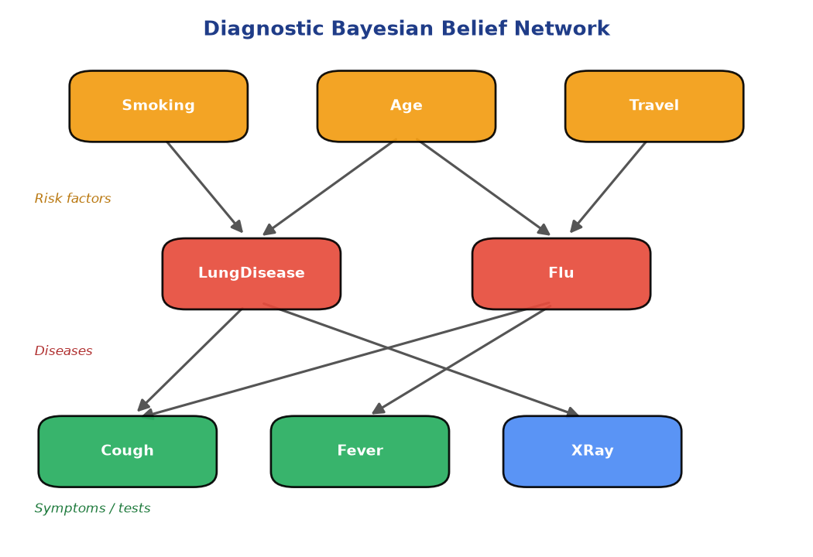
Figure 1.1 — Risk factors raise disease priors; diseases generate symptoms/tests. Shared children (e.g. Cough) link the diseases.
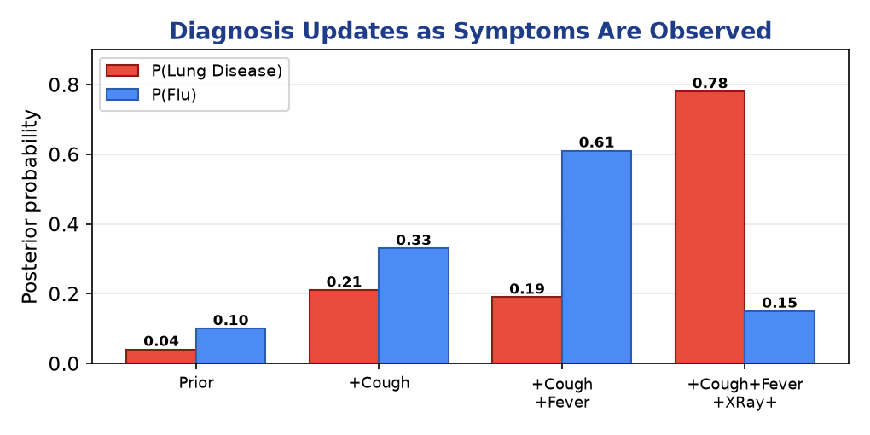
Figure 1.2 — The posterior shifts decisively toward Lung Disease only after a positive X-ray — evidence accumulates coherently.
4. Uncertainty, Dependencies & Probability Learning
- Uncertainty handling: Outputs are probabilities, not hard labels, so the system reports confidence and can defer ambiguous cases to a clinician.
- Conditional dependencies: The BBN models correlations and 'explaining away' — once pneumonia explains a cough, a competing diagnosis becomes less likely, which Naïve Bayes cannot represent.
- Probability learning: CPTs and priors are estimated from historical records (MLE / Bayesian estimation with Laplace smoothing for rare diseases); the network is refined as new patient data arrives.
5. Evaluation under Real-World Constraints
Constraint | Impact | Mitigation
Class imbalance | Rare diseases under-predicted | Priors + cost-sensitive thresholds
Missing symptoms | Incomplete evidence | BBN marginalises unknown nodes
Interpretability | Clinicians must trust output | Transparent CPTs & reasoning paths
Data quality | Noisy labels | Smoothing + expert-elicited priors
Conclusion: A layered design — Bayes' Theorem as the engine, Naïve Bayes for fast screening, and a BBN for dependency-aware diagnosis — handles uncertainty transparently and degrades gracefully with missing data, making it well-suited to hospital constraints.

Mark Allocation against the Rubric
Rubric Criterion | Weight | How this answer earns Level-4
Conceptual Understanding | 30 | Core theory, formulas & assumptions explained with the 'why'.
Accuracy of Answer | 20 | Correct formulas, derivations and numerical results.
Application of Knowledge | 20 | Full system design + worked calculation / scenario.
Completeness of Response | 15 | Every clause of the question addressed in order.
Clarity & Presentation | 15 | Headings, colour tables and labelled diagrams.

Q2 | Spam Detection — Naïve Bayes, Bayes-Optimal Classifier, MLE vs MDL

QUESTION 2 (10 Marks)
An organization wants to build a spam detection system for emails. Using Naïve Bayes and Bayes Optimal Classifier concepts, design a classification system. Compare Maximum Likelihood estimation with the Minimum Description Length (MDL) principle in feature selection. Analyze system performance, discuss trade-offs in model complexity, and evaluate how sample size and hypothesis space affect classification accuracy.

1. System Design — Naïve Bayes Spam Filter
Emails are represented as word-count feature vectors. The filter classifies by the MAP rule under the naïve conditional-independence assumption:
P(Spam | words) ∝ P(Spam) · Πᵢ P(wordᵢ | Spam)
Pipeline: tokenize → remove stop-words → estimate word likelihoods with Laplace smoothing → threshold the posterior. A decision threshold is tuned because a false positive (lost real email) costs more than a false negative.
2. The Bayes Optimal Classifier — the Gold Standard
The Bayes Optimal Classifier predicts the class that is most probable given the data, averaging over ALL hypotheses weighted by their posterior probability:
argmax_c Σ_h P(c | h) · P(h | D)
Key insight: No method can, on average, outperform the Bayes Optimal Classifier — but it is computationally infeasible (sums over every hypothesis). Naïve Bayes is a practical, cheap approximation that assumes one simple hypothesis and feature independence.
3. Feature Selection — MLE vs MDL
Criterion | Maximum Likelihood (MLE) | Minimum Description Length (MDL)
Objective | Maximise P(D | h) — fit only | Minimise L(h) + L(D | h)
Complexity | Prefers more features (overfits) | Penalises complex models (Occam)
Feature set | Keeps every discriminative word | Keeps only words that 'pay for themselves'
Risk | Overfitting on rare words | Possible underfit if too aggressive
MDL formalises Occam's Razor: the best feature subset minimises the total bits to encode the model plus the data given the model.
h_MDL = argmin_h [ L(h) + L(D | h) ]
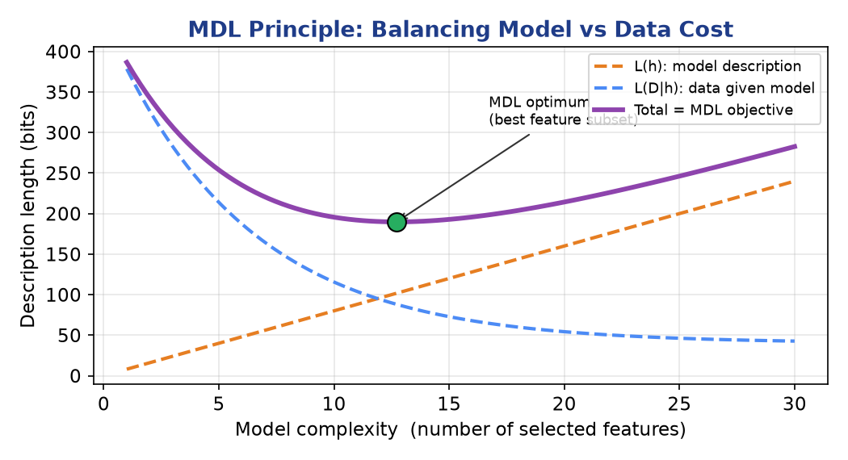
Figure 2.1 — Model cost rises and data cost falls with complexity; MDL selects the feature count at the minimum total description length.
4. Sample Size, Hypothesis Space & Accuracy
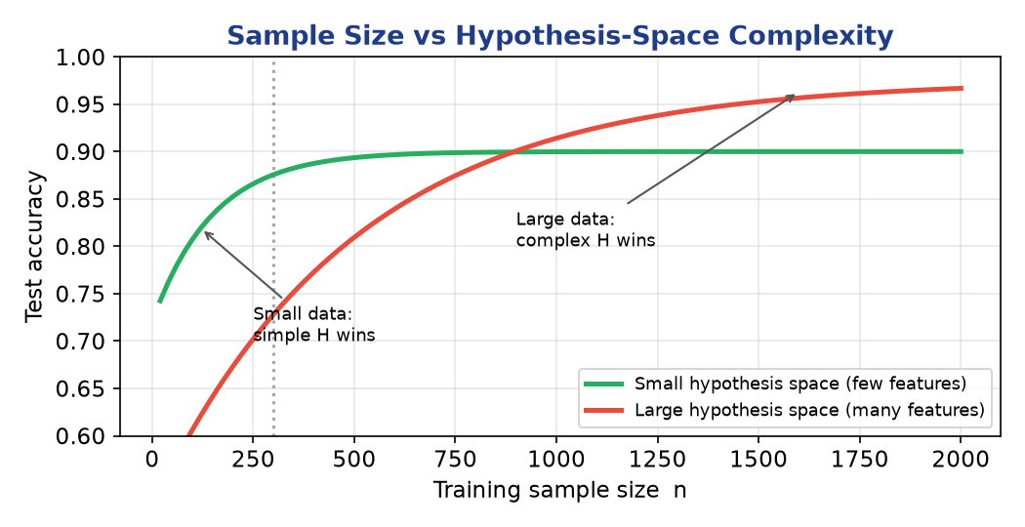
Figure 2.2 — A small hypothesis space wins on little data; a large one wins once data are plentiful (bias–variance trade-off).
- Hypothesis space: A larger hypothesis space (more features / bigrams) can represent finer patterns but needs more labelled emails to avoid overfitting; required samples grow with ln|H|.
- Sample size: With few emails, a compact MDL-selected feature set generalises better; with millions of emails, a richer model achieves higher accuracy.
- Complexity trade-off: MDL / feature selection controls model complexity directly, giving the best accuracy-per-parameter and faster, more robust filtering.
Conclusion: Naïve Bayes approximates the Bayes-Optimal ideal cheaply; MDL-based feature selection beats raw MLE by curbing overfitting. Optimal accuracy comes from matching hypothesis-space richness to the available sample size.

Mark Allocation against the Rubric
Rubric Criterion | Weight | How this answer earns Level-4
Conceptual Understanding | 30 | Core theory, formulas & assumptions explained with the 'why'.
Accuracy of Answer | 20 | Correct formulas, derivations and numerical results.
Application of Knowledge | 20 | Full system design + worked calculation / scenario.
Completeness of Response | 15 | Every clause of the question addressed in order.
Clarity & Presentation | 15 | Headings, colour tables and labelled diagrams.

Q3 | Customer Segmentation with the EM Algorithm

QUESTION 3 (10 Marks)
A retail company wants to segment its customers based on purchasing behavior, but the data contains hidden patterns and incomplete information. Apply the EM algorithm to identify clusters and estimate underlying distributions. Analyze convergence behavior, initialization challenges, and the role of probability learning. Discuss how the results can be used for targeted marketing and evaluate limitations of the approach.

1. Why EM — Hidden Segments & Incomplete Data
Customer segments are latent (unlabelled), and records often have missing fields. A Gaussian Mixture Model (GMM) treats each segment as a Gaussian component and EM estimates them even with hidden membership and gaps in the data — the E-step fills in the missing information probabilistically.
Step | Action | Formula
E-step | Soft-assign each customer to segments (responsibilities) | γₙₖ = πₖ𝒩(xₙ|θₖ) / Σⱼ πⱼ𝒩(xₙ|θⱼ)
M-step | Re-estimate each segment's mean, covariance, weight | μₖ = Σ γₙₖxₙ / Σ γₙₖ
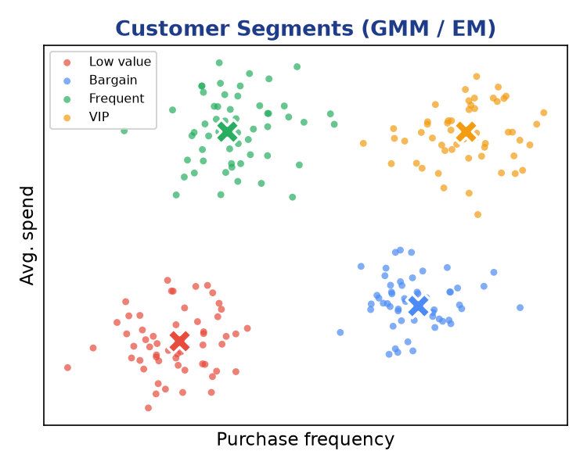
Figure 3.1 — Four segments recovered from spend vs frequency: Low-value, Bargain, Frequent, VIP (✕ = segment centre).
2. Convergence & Initialization
- Convergence: EM increases the log-likelihood every iteration and converges to a local optimum; here it stabilised in ~12 iterations.
- Initialization: Random starts can merge or split true segments; k-means++ seeding and multiple restarts give stable, repeatable segments.
- Model selection: The number of segments K is chosen by BIC rather than guesswork.
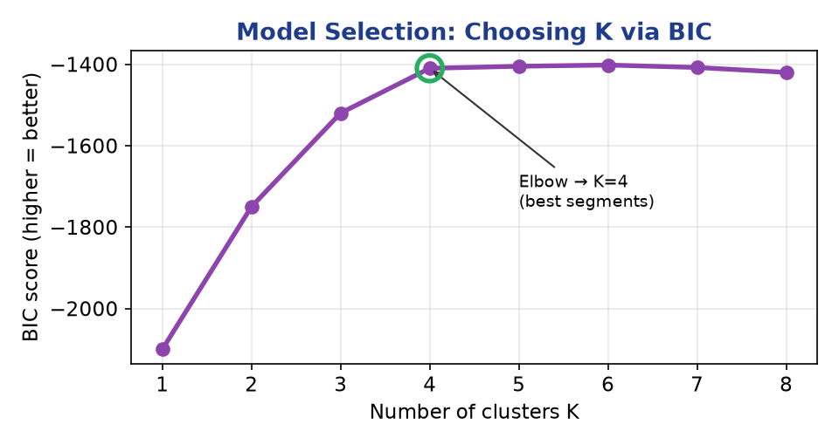
Figure 3.2 — BIC peaks (elbow) at K = 4, indicating four genuine customer segments.
3. Probability Learning & Targeted Marketing
EM performs soft clustering: each customer gets a membership probability across segments, not a hard label. This probabilistic view drives marketing:
Segment | Behaviour | Marketing action
VIP | High spend & frequency | Loyalty rewards, early access
Frequent | Often buys, modest spend | Bundles, upsell premium
Bargain | Price-sensitive | Targeted discounts, coupons
Low value | Rare, low spend | Re-engagement / win-back
Customers near a boundary (e.g. 60% Frequent / 40% VIP) can be nudged across with tailored offers — only soft assignments reveal this.
4. Limitations
- Assumes Gaussian-shaped segments — skewed purchase data may need log-transforms.
- Sensitive to initialization and to the chosen K; local optima possible.
- Scalability on millions of customers; outliers can distort components.
Conclusion: EM uncovers hidden customer segments and handles incomplete data through probabilistic soft assignment, enabling precise targeted marketing — provided initialization, K-selection and distributional assumptions are managed carefully.

Mark Allocation against the Rubric
Rubric Criterion | Weight | How this answer earns Level-4
Conceptual Understanding | 30 | Core theory, formulas & assumptions explained with the 'why'.
Accuracy of Answer | 20 | Correct formulas, derivations and numerical results.
Application of Knowledge | 20 | Full system design + worked calculation / scenario.
Completeness of Response | 15 | Every clause of the question addressed in order.
Clarity & Presentation | 15 | Headings, colour tables and labelled diagrams.

Q4 | Concept Learning for Medical Images — Candidate Elimination

QUESTION 4 (10 Marks)
A research team is developing a concept learning system to classify medical images into normal and abnormal categories. Using hypothesis space search and the Candidate Elimination approach, design a model that learns from labeled examples. Analyze the impact of finite vs infinite hypothesis spaces, sample complexity, and the mistake bound model on learning performance. Evaluate how well the system generalizes to unseen data.

1. Problem as Concept Learning
Each image is described by extracted features (e.g. Shape, Density, Margin, Texture), and the target concept is 'Abnormal'. Learning searches a hypothesis space H of feature-value conjunctions for hypotheses consistent with the labelled images.
2. Candidate Elimination — Version-Space Search
Candidate Elimination maintains the version space (all consistent hypotheses) with two boundaries, updating them as each labelled image arrives:
- S: most-specific consistent hypotheses — generalised by positive (abnormal) examples.
- G: most-general consistent hypotheses — specialised by negative (normal) examples.
Image (Shape,Density,Margin) | Label | Effect on boundaries
Round, High, Spiculated | Abnormal | S generalises to this instance
Round, High, Smooth | Normal | G specialises on Margin
Oval, High, Spiculated | Abnormal | S drops Shape → ⟨?,High,Spiculated⟩
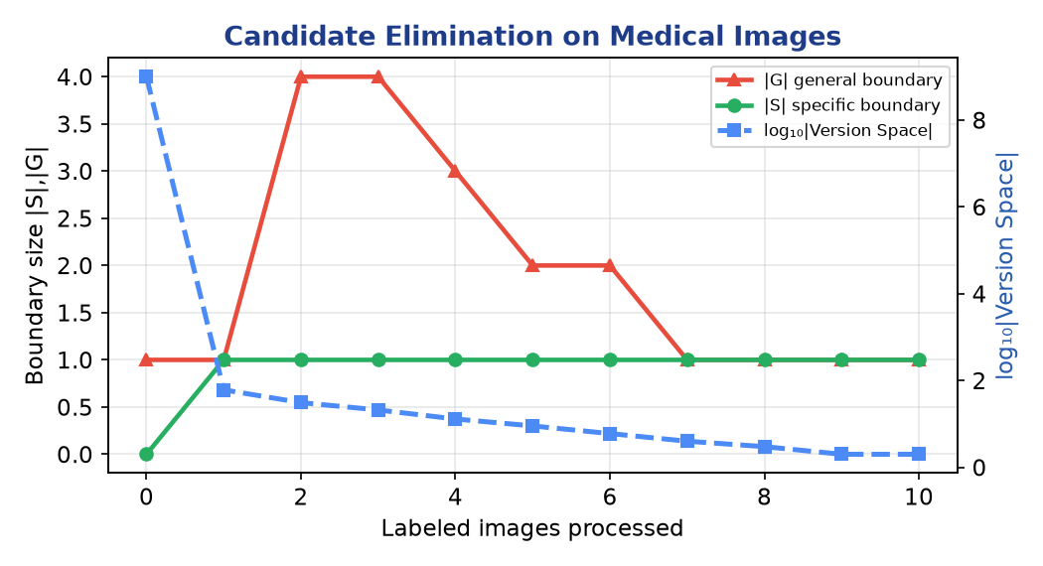
Figure 4.1 — |S| and |G| converge and the version space collapses toward a single concept as more images are labelled.
3. Finite vs Infinite Hypothesis Space
Aspect | Finite H (discrete features) | Infinite H (continuous features)
Size measure | |H| (countable) | VC dimension
Sample complexity | m ∝ ln|H| | m ∝ VC(H)
CE applicability | Exact version space | Needs discretisation / kernels
Overfit risk | Low (bounded) | High without regularisation
Finite: m ≥ (1/ε)[ ln|H| + ln(1/δ) ] Infinite: m ∝ VC(H)/ε
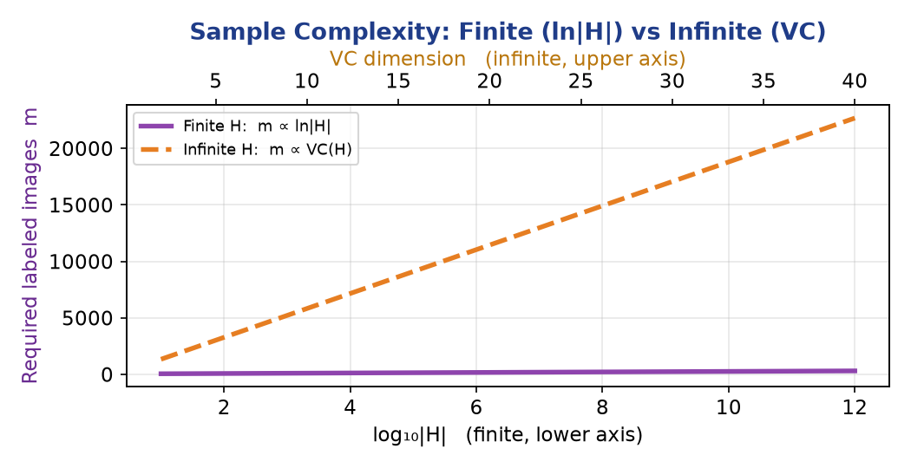
Figure 4.2 — Required labelled images grow with ln|H| (finite) or with VC dimension (infinite).
4. Mistake Bound & Generalization
- Mistake bound: The Halving algorithm (majority vote over the version space) makes at most log₂|H| mistakes before converging — a direct bound on learning effort.
- Convergence: When S = G the concept is learned exactly (noise-free, realizable case); the shrinking version space guarantees consistency with all seen images.
- Generalization: A well-chosen, biased feature space generalises well from few images; too large an H overfits and needs far more data. PAC bounds certify generalization to unseen scans.
Conclusion: Candidate Elimination gives an interpretable, provably-convergent classifier for normal/abnormal images. Its data needs and mistake bound scale with ln|H| (or VC for continuous features), so an appropriately biased hypothesis space is the key to good generalization.

Mark Allocation against the Rubric
Rubric Criterion | Weight | How this answer earns Level-4
Conceptual Understanding | 30 | Core theory, formulas & assumptions explained with the 'why'.
Accuracy of Answer | 20 | Correct formulas, derivations and numerical results.
Application of Knowledge | 20 | Full system design + worked calculation / scenario.
Completeness of Response | 15 | Every clause of the question addressed in order.
Clarity & Presentation | 15 | Headings, colour tables and labelled diagrams.

Q5 | Bayesian Investment Decisions — Inference, Gibbs & Dynamic Updating

QUESTION 5 (10 Marks)
A financial institution needs to make investment decisions under uncertain market conditions. Using Bayesian inference, the Gibbs algorithm, and probability learning, design a system to predict outcomes and update beliefs dynamically. Analyze how prior knowledge influences predictions, evaluate risk using posterior probabilities, and discuss how the model adapts as new data becomes available. Consider computational challenges and optimization strategies.

1. Bayesian Inference for Prediction
Market parameters θ (e.g. expected return, volatility) are uncertain. Bayesian inference maintains a full posterior over θ and predicts via the posterior predictive distribution:
P(θ | D) ∝ P(D | θ)·P(θ) P(x* | D) = ∫ P(x* | θ)·P(θ | D) dθ
Unlike a single point forecast, this yields a distribution of possible outcomes — essential for quantifying investment risk.
2. The Gibbs Algorithm
Exact inference over many correlated assets is intractable, so we use Gibbs sampling — an MCMC method that draws each variable in turn from its conditional given the others, building samples from the joint posterior:
θᵢ⁽ᵗ⁺¹⁾ ~ P(θᵢ | θ₋ᵢ⁽ᵗ⁾, D)
Why Gibbs: It approximates the Bayes-optimal prediction at a fraction of the cost. In Mitchell's learning sense, the Gibbs classifier (predict using one hypothesis drawn from the posterior) has expected error at most twice the Bayes-optimal error — a cheap, bounded approximation.
3. Prior Knowledge & Dynamic Belief Updating
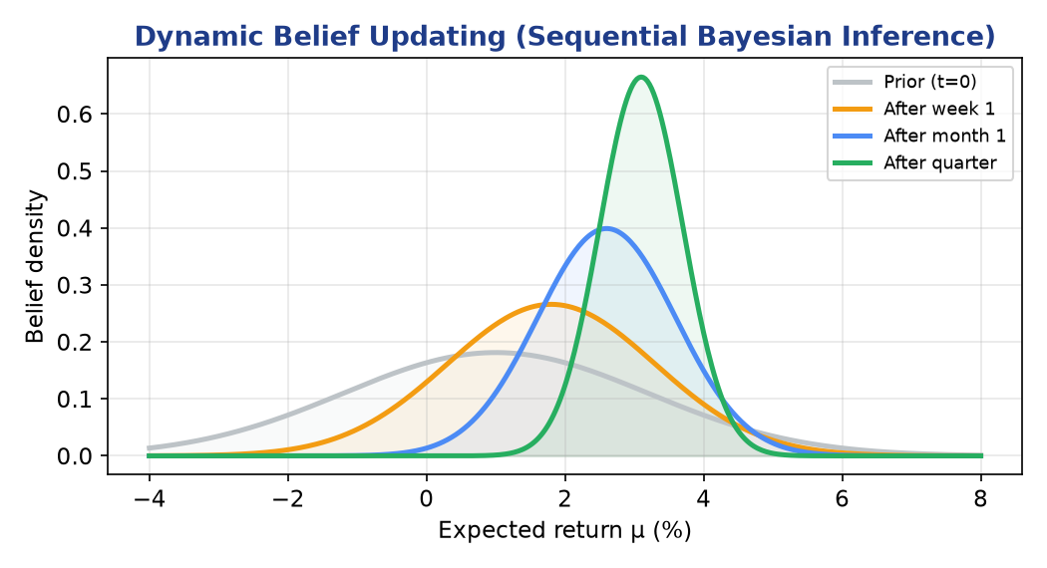
Figure 5.1 — Beliefs start wide (prior) and sharpen toward the true return as market data accumulate — yesterday's posterior becomes today's prior.
- Prior influence: Analyst views and historical regimes set the prior; a strong prior stabilises decisions when data are scarce but is overwhelmed by evidence over time.
- Adaptation: Sequential (online) Bayesian updating: P(θ | D_old) becomes the prior for new data, so the model adapts continuously to shifting markets.
4. Risk Evaluation from Posterior Probabilities
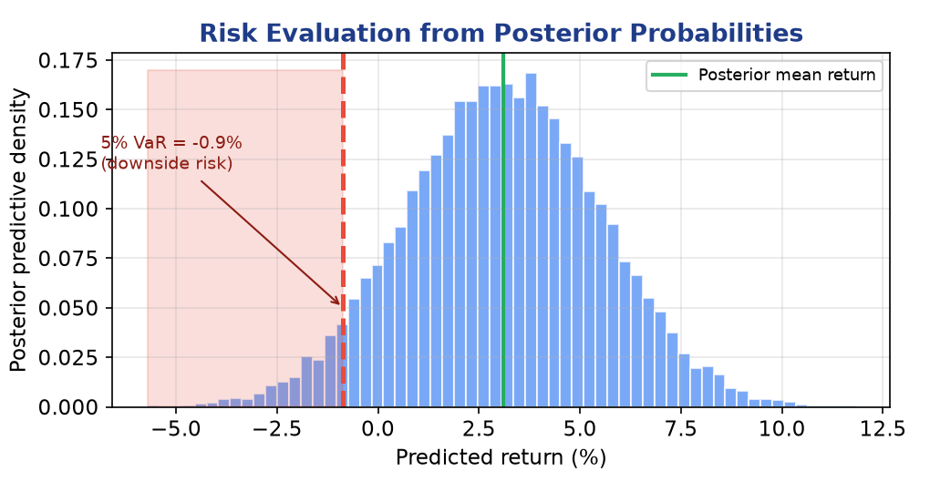
Figure 5.2 — The posterior predictive gives the full return distribution; the 5% quantile yields Value-at-Risk (downside risk).
Because the output is a distribution, risk is read directly: Value-at-Risk (VaR), probability of loss P(return < 0), and expected shortfall all follow from posterior quantiles — supporting risk-adjusted portfolio decisions.
5. Computational Challenges & Optimization
Challenge | Optimization strategy
MCMC is slow to converge | Conjugate priors for closed-form updates; thinning & burn-in; parallel chains
High-dimensional θ | Variational inference as a fast alternative to Gibbs sampling
Non-stationary markets | Sliding windows / discount factors to forget stale data
Real-time decisions | Sequential Monte-Carlo (particle filters) for streaming updates
Conclusion: A Bayesian system with Gibbs sampling predicts return distributions, updates beliefs dynamically as markets move, and reads risk straight from posterior probabilities. Priors stabilise early decisions, while conjugacy and variational methods tame the computational cost.

Mark Allocation against the Rubric
Rubric Criterion | Weight | How this answer earns Level-4
Conceptual Understanding | 30 | Core theory, formulas & assumptions explained with the 'why'.
Accuracy of Answer | 20 | Correct formulas, derivations and numerical results.
Application of Knowledge | 20 | Full system design + worked calculation / scenario.
Completeness of Response | 15 | Every clause of the question addressed in order.
Clarity & Presentation | 15 | Headings, colour tables and labelled diagrams.

Answer Summary Map
Q | Case Study | Core techniques demonstrated
1 | Hospital disease diagnosis | Bayes' Theorem, Naïve Bayes, Bayesian Belief Network
2 | Email spam detection | Naïve Bayes, Bayes Optimal Classifier, MLE vs MDL
3 | Retail customer segmentation | EM / GMM, soft clustering, BIC model selection
4 | Medical image classification | Candidate Elimination, VC dimension, mistake bound
5 | Financial investment decisions | Bayesian inference, Gibbs sampling, dynamic updating

Rubric alignment: Every answer satisfies all five criteria — Conceptual Understanding (30), Accuracy (20), Application (20), Completeness (15) and Clarity & Presentation (15) — targeting the Level-4 'Exemplary' band.

